

_{LAB REPORT 08}

SUBMITTED TO: MR. MUBASHIR IQBAL
SUBMITTED BY: AHMED SALEEM RANA
_{REG ID: 24-CYS-023}
_{SECTION: B}

_{HITEC UNIVERSITY TAXILA, CANTT}
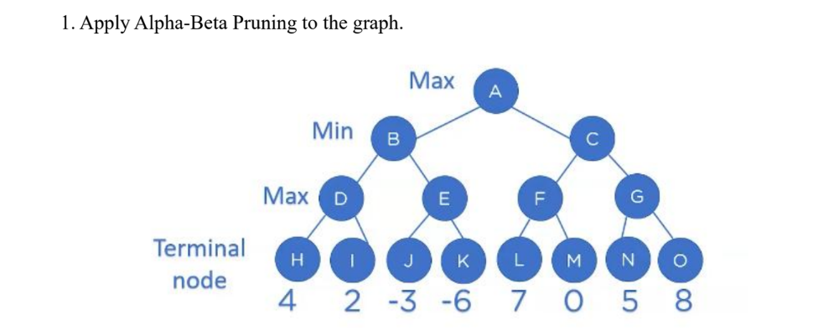
TASK 01

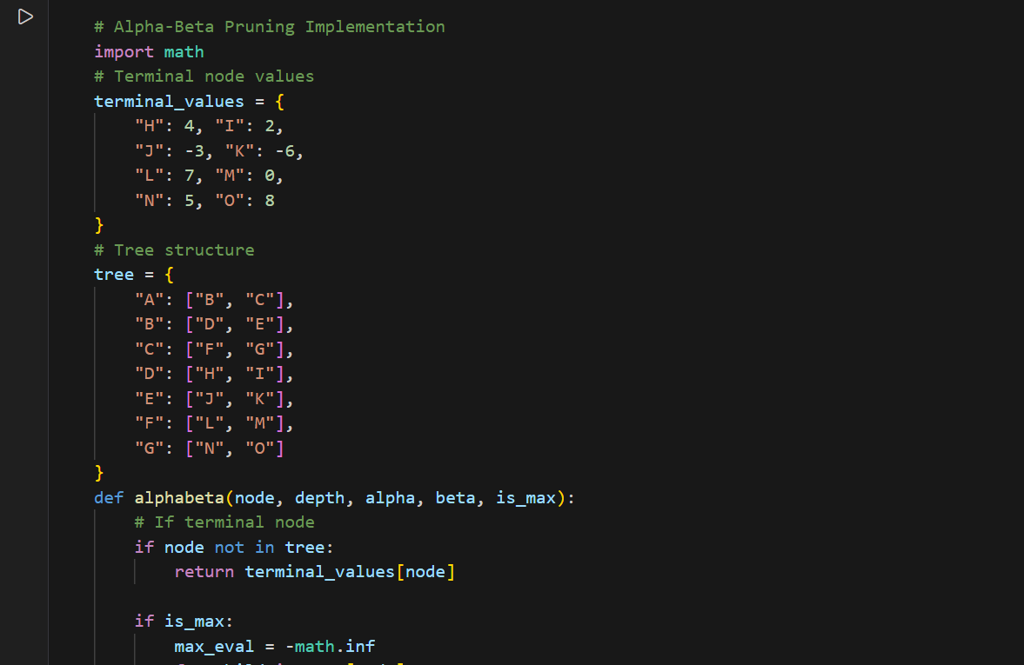
CODE:
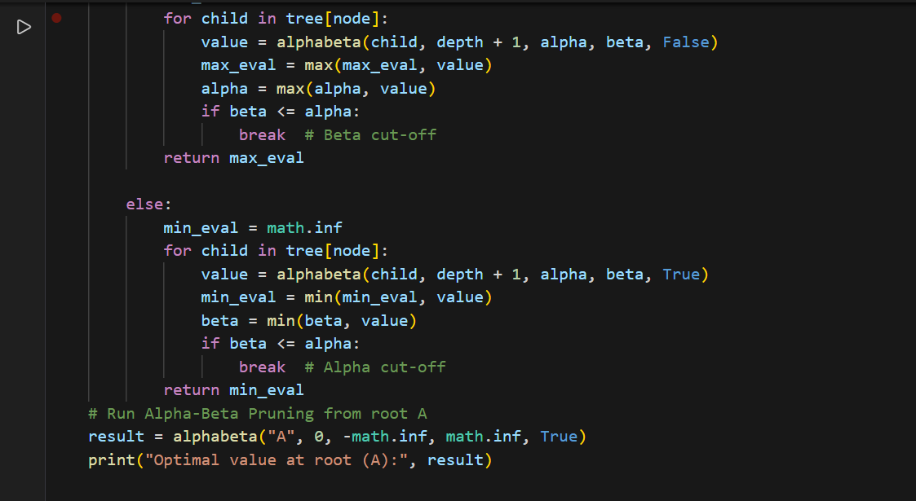
OUTPUT:
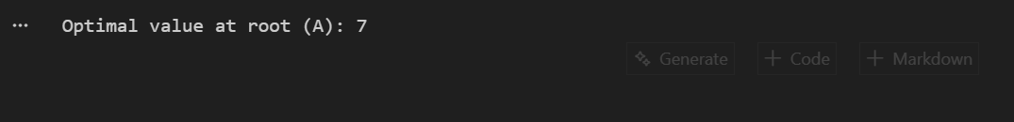

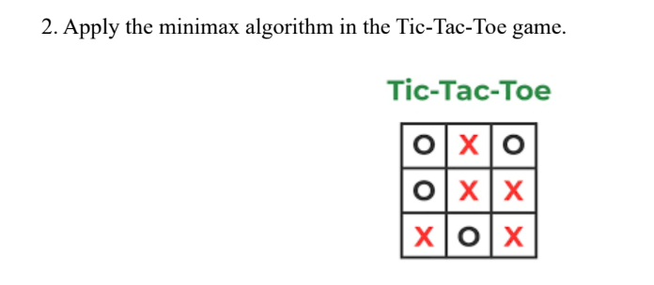
TASK 02
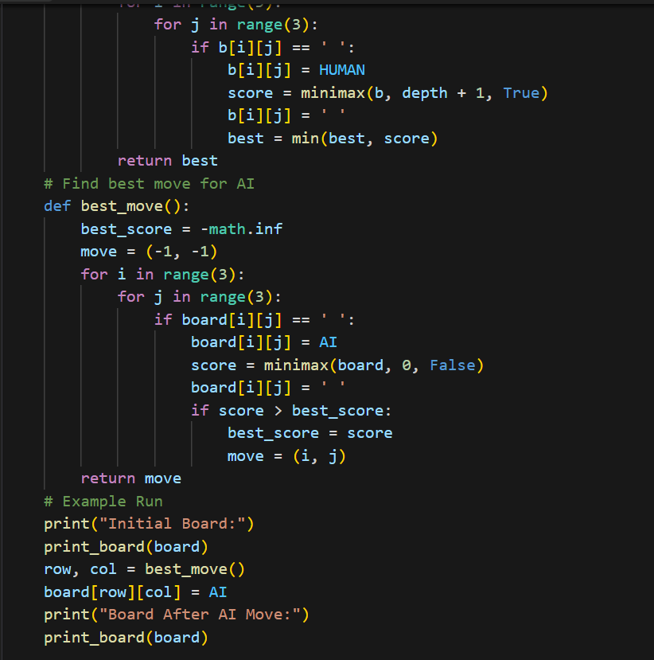
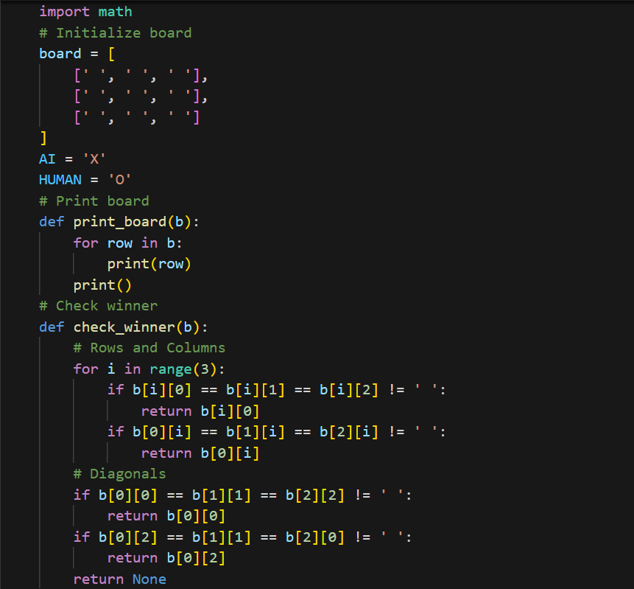
CODE:
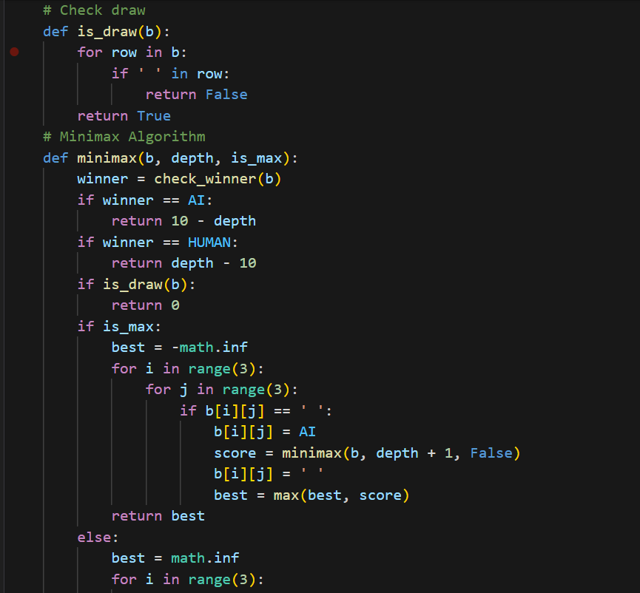
OUTPUT:
